1)
 | Forward Biased | Reverse Biased
Vdiode | 608,9 | 0.0

2)
Circuit fig.6a R=220Ω

Diode Volts | diyote Volts (measured) | Current
.35 | .348 | 0
.40 | .3977 | .0164 ma
.45 | .4505 | .0418 ma
.50 | .5019 | .1136 ma
.55 | .5531 | .2753 ma
.60 | .6072 | .7353 ma
.65 | .6572 | 1.9214 ma
.70 | .7048 | 5.9214 ma
.75 | .749 | 13.005 ma
.80 | .801 | 28.22 ma
.85 | .8541 | 50.56 ma
.90 | .895 | 80.69 ma

3) Aynı devreyi R.= 1 M Ω ile kurduğumuzda

Source  Voltage | Silicon diyote 1N4148
Source  Voltage | Vresistor(measured) | Vdiode (calculated) | Idiode(Calculated)
0 | 0 | 0 | 0
-1 | 0.475 mv | -0.99 | 0.99 ma
-2 | 0.515 mv | -1.994 | 1.994 ma
-3 | 5.58 mv | -2.994 | 2.994
-4 | 5.87 mv | -3.994 | 3.994
-5 | 6.9 mv | -4.993 | 4.993
-10 | 7.28 mv | -9.992 | 9.992
-15 | 8.35 mv | -14.991 | 14.991
-20 | 9.04 | -19.99 | 19.991
-25 | 9.62 | 24.9038 | 24.9038

4)
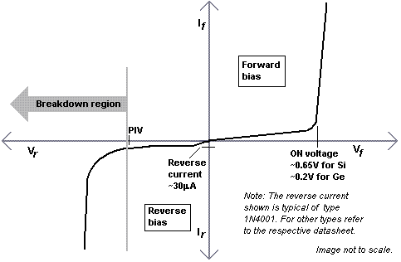

5)

